Book
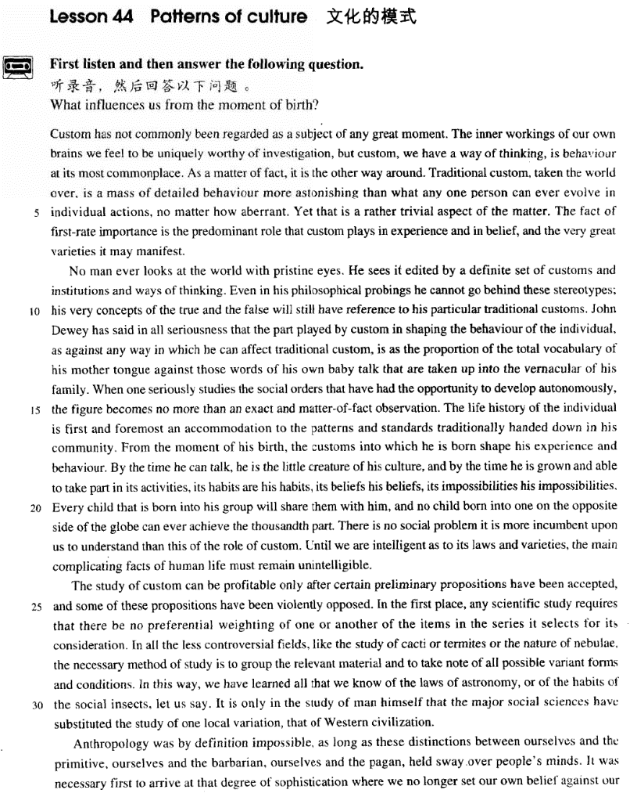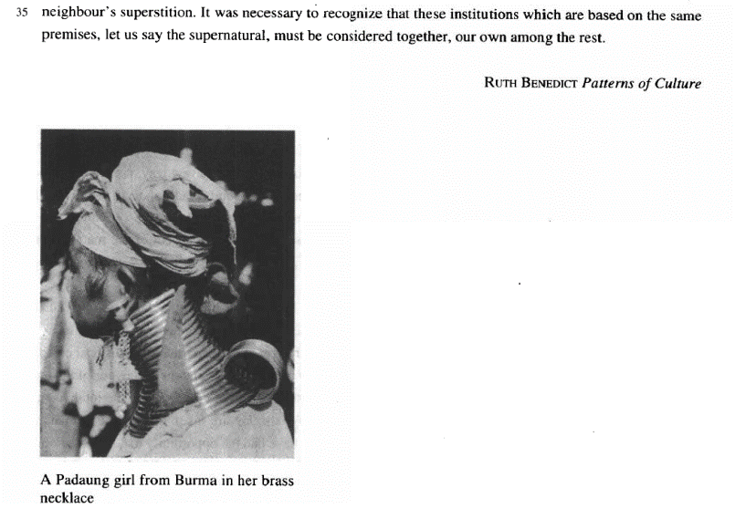

课文
Custom has not commonly been regarded as a subject of any great moment.
风俗一般未被认为是什么重要的课题。

The inner workings of our own brains we feel to be uniquely worthy of investigation, but custom, we have a way of thinking, is behaviour at is most commonplace.
我们觉得只有我们大脑内部的活动情况才值得研究，至于风俗呢，只是些司空见惯的行为而已。

As a matter of fact, it is the other way around.
事实上，情况正好相反。

Traditional custom, taken the world over, is a mass of detailed behaviour more astonishing than what any one person can ever evolve in individual actions, no matter how aberrant.
从世界范围来看，传统风俗是由许多细节性的习惯行为组成，它比任何一个养成的行为都更加引人注目，不管个人行为多么异常。

Yet that is a rather trivial aspect of the matter.
这只是问题的一个次要的侧面。

The fact of first-rate importance is the predominant role that custom plays in experience and in belief, and the very great varieties it may manifest.
最重要的是，风俗在实践中和信仰上所起的举足轻重的作用，以及它所表现出来的极其丰富多采的形式。

No man ever looks at the world with pristine eyes.
没有一个人是用纯洁而无偏见的眼光看待世界。

He sees it edited by a definite set of customs and institutions and ways of thinking.
人们所看到的是一个受特定风俗习惯、制度和思想方式剪辑过的世界。

Even in his philosophical probings he cannot go behind these stereotypes; his very concepts of the true and the false will still have reference to his particular traditional customs.
甚至在哲学领域的探索中，人们也无法超越这此定型的框框；人们关于真与伪的概念依然和特定的传统风俗有关。

John Dewey has said in all seriousness that the part played by custom in shaping the behaviour of the individual, as against any way in which he can affect traditional custom, is as the proportion of the total vocabulary of his mother tongue against those words of his own baby talk that are taken up into the vernacular of his family.
约翰.杜威曾经非常严肃地指出：风俗在形成个人行为方面所起的作用和一个对风俗的任何影响相比，就好像他本国语言的总词汇量和自己咿呀学语时他家庭所接纳的他的词汇量之比。

When one seriously studies the social orders that have had the opportunity to develop autonomously, the figure becomes no more than an exact and matter-of-fact observation.
当一个人认真地研究自发形成的社会秩序时，杜威的比喻就是他实事求是观察得来的形象化的说法。

The life history of the individual is first and foremost an accommodation to the patterns and standards traditionally handed down in his community.
个人的生活史首先是适应他的社团世代相传形成的生活方式和准则。

From the moment of his birth, the customs into which he is born shape his experience and behaviour.
从他呱呱坠地的时刻起，他所生于其中的风俗就开始塑造他的经历和行为规范。

By the time he can talk, he is the little creature of his culture, and by the time he is grown and able to take part in its activities, its habits are his habits, its beliefs his beliefs, its impossibilities his impossibilities.
到会说话时，他就是传统文化塑造的一个小孩子；等他长大了，能做各种事了，他的社团的习惯就是他的习惯，他的社团的信仰就是他的信仰，他的社团不能做的事就是他不能做的事。

Every child that is born into his group will share them with him, and no child born into one on the opposite side of the globe can ever achieve the thousandth part.
每一个和他诞生在同一个社团中的孩子和他一样具有相同的风俗；而在地球的另一边，诞生在另一个社团的孩子与他就是少有相同的风俗。

There is no social problem it is more incumbent upon us to understand than this of the role of custom.
没有任何一个社会问题比得上风俗的作用问题更要求我们对它理解。

Until we are intelligent as to its laws and varieties, the main complicating facts of human life must remain unintelligible.
直到我们理解了风俗的规律性和多样性，我们才能明白人为生活中主要的复杂现象。

The study of custom can be profitable only after certain preliminary propositions have been accepted, and some of these propositions have been violently opposed.
只有在某些基本的主张被接受下来、同时有些主张被激烈反对时，对风俗的研究才是全面的，才会有收获。

In the first place, any scientific study requires that there be no preferential weighting of one or another of the items in the series it selects for its consideration.
首先，任何科学研究都要求人们对可供考虑的诸多因素不能厚此薄彼，偏向某一方面。

In all the less controversial fields, like the study of cacti or termites or the nature of nebulae, the necessary method of study is to group the relevant material and to take note of all possible variant forms and conditions.
在一切争议较小的领域里，如对仙人掌、白蚁或星云性质的研究，应采取的研究方法是把有关各方面的材料汇集起来，同时注意任何可能出现的异常情况和条件。

In this way, we have learned all that we know of the laws of astronomy, or of the habits of the social insects, let us say.
例如，用这种方法，我们完全掌握了天文学的规律和昆虫群居的习性。

It is only in the study of man himself that the major social sciences have substituted the study of one local variation, that of Western civilization.
只是在对人类自身的研究，主要的社会科学建立在本土变化，即西方文明上。

Anthropology was by definition impossible, as long as these distinctions between ourselves and the primitive, ourselves and the barbarian, ourselves and the pagan, held sway over people's minds.
只要我们同原始人，我们同野蛮人，我们同异教徒之间存有的区别在人的思想中占主工导地位，那么人类学按其定义来说就无法存在。

It was necessary first to arrive at that degree of sophistication where we no longer set our own belief against our neighbour's superstition.
我们首先需要达到这样一种成熟的程度：不用自己的信仰去反对我们邻居的迷信。

It was necessary to recognize that these institutions which are based on the same premises, let us say the supernatural, must be considered together, our own among the rest.
必须认识到，这些建立在相同前提基础上的风俗，暂且可以说是超自然的东西，必须放在一起加以考虑，我们自己的风俗和其他民族的风俗都在其中。

词汇讲解

predominant
- predominant [prɪ'dɒmɪnənt] adj. 显著的，主要的，多数的
predominant adj. 英文解释：more noticeable or important, or larger in number, than others 显著的，主要的，多数的
- Research forms the predominant part of my job.
- Dancers have a predominant role in this performance.

【同根词】
predominate v. 占多数，最重要，最显著
- In older age groups women predominate because men tend to die younger.
- Private interest was not allowed to predominate over the public good.

predominance n. 多数，优势
- a predominance of boys in the class
- Britain's naval predominance

【词根】
“dom” = rule

dominate v. 统治，支配，占优势
dominant adj. 最重要的，占支配地位的
domination n. 统治，支配
dominion n. 统治，管辖；领土，版图

“pre” = before
predominate v. 占多数，最重要，最显著
predominant adj. 显著的，主要的，多数的
predominance n. 多数，优势

incumbent
- incumbent [ɪn'kʌmbənt] adj. 有责任，有义务，必须履行的；现任的
incumbent adj. 含义1. necessary as part of sb’s duty 有责任，有义务，必须履行的
incumbent on / upon sb. 责任在…身上
- It is incumbent upon all users of this equipment to familiarize themselves with the safety procedure.

incumbent adj. 含义2. having an official position 现任的
- the incumbent president

【词根】
“cumb” = lie down 躺下

“in” = into
incumbent adj. 有责任，有义务，必须履行的；现任的

“en” = in
encumber v. 妨碍，阻碍

“some”（形容词后缀）
cumbersome adj. 笨重的

“con” = together
concubine n. 妾，姨太太，小老婆

“sub” = under
succumb v. 屈从，服从

“re” = back
recumbent adj. 躺着的

cactus
- cactus ['kæktəs] n. 仙人掌
【扩展】拉丁词复数变化：
cactus ➔ 复数 cacti / cactuses
stimulus ➔ 复数 stimuli
bacillus ➔ 复数 bacilli
alumnus ➔ 复数 alumni

nebula
- nebula ['nebjələ] n. 星云
nebula 英文解释：n. a mass of gas and dust among the stars, which often appears as a bright cloud in the sky at night 星云

【扩展】复数变化：
nebula 复数 nebulae
larva 复数 larvae
alumna ➔ 复数 alumnae

barbarian
- barbarian [bɑ:'beəriən] n. 野蛮人；没有教养的人
barbarian n. 含义1. a member of a group of people from a very different country or culture that is considered to be less socially advanced and more violent than your own 野蛮人
- barbarian invasions of the fifth century

barbarian n. 含义2. a person with little education who has no interest in art and culture 没有教养的人
- How can you call those barbarians your friends?

【同根词】
barbarous = barbaric adj. 野蛮的
- the barbarous treatment of these prisoners of war
- It's a devastating and barbaric act that defies all comprehension.

barbarism n. 野蛮
- The terrorist attack was condemned as an act of barbarism and cowardice.

【反义词】
civilized adj. 文明的
- Such things should not be allowed to happen in a civilized society.

civilization n. 文明
- Each civilization is born, it culminates, and it decays.

sophistication
- sophistication [sə7fɪstɪ'keɪʃn] n. 高级，复杂，先进；老练，世故； 聪明，有经验，理解力强
sophistication n. 含义1. the sophistication of machines or methods is their quality of being more advanced or complex than others 高级，复杂，先进
- Given the sophistication of modern machines, there is little that cannot be successfully washed at home.

sophistication n. 含义2. the quality of being comfortable in social situations and knowing about culture, fashion, and other matters that are considered socially important 老练，世故
- She spoke simply and directly, without sophistication.

sophistication n. 含义3. the quality of being intelligent and knowing a lot, so that you are able to understand complicated situations 聪明，有经验，理解力强
- computer users with a high degree of sophistication

【同根词】
sophisticated adj. 含义1. (of machine, device, or method) more advanced or complex than others 高级的，复杂的，先进的
- sophisticated modern weapons
- Bees use one of the most sophisticated communication systems of any insect.

sophisticated adj. 含义2. comfortable in social situations and knows about culture, fashion, and other matters that are considered socially important 老练的，世故的
- He was older than me and from London and I thought him very sophisticated.

sophisticated adj. 含义3. intelligent and knows a lot, so that they are able to understand complicated situations 聪明的，有经验的，理解力强的
- Consumers are getting more sophisticated and more demanding.

课文讲解

（第一段）

Custom has not commonly been regarded as a subject of any great moment.

语法分析：
Custom has not commonly been regarded as a subject of great moment（后置定语）.

知识点（1）【词汇】
commonly adv. usually; widely 通常；广泛地
- The disease is commonly known as mad cow disease.
- a commonly used industrial chemical

知识点（2）【词汇】
moment n. 英文解释：outstanding significance or value, importance 重要
… of great moment 非常重要的
- a discovery of great moment

【同根词】
momentous adj. vital, crucial, key, critical 重要的，重大的，关键的

The inner workings of our own brains we feel to be uniquely worthy of investigation, but custom, we have a way of thinking, is behaviour at is most commonplace.

语法分析：
The inner workings of our own brains（宾语，前置） we（主语） feel（谓语） to be uniquely worthy of investigation（宾语补足语）, but custom, we have a way of thinking（插入语）, is behaviour at its most commonplace（后置定语）.

知识点（1）
the workings of sth. 英文解释：the way that an organization, machine or organism operates 工作方式，运作方式，运转方式
- the workings of government
- the workings of a car engine

知识点（2）
语法：宾语前置，突出
- The inner workings of our own brains we feel to be uniquely worthy of investigation, …
- We feel the inner workings of our brains to be uniquely worthy of investigation, …

- Smoking he absolutely loathes.
- That John is a thief I can’t believe.
- The president praised the loyalists, but the rebels he declared traitors.

语法：宾语后置（宾语太长）
- He has proved them wrong.
- He has proved wrong the forecasts made by the country’s leading economic experts（宾语后置）.
- In 1928 some porpoises were photographed working like beavers to push ashore a waterlogged mattress.
- It has to be tall because it is like a giant block and tackle, and we have to lower into the ground and haul out of the ground great lengths of drill pipe which are rotated by an engine at the top and are fitted with a cutting bit at the bottom.

知识点（3）Lesson03-04
表达“值”：
worth （可以看做介词）
be worth sth.
be worth doing
- He will be earning only half as much as he used to, but he feels that his rise in status is well worth the loss of money.
- The matter is worth consideration.
- The matter is worth considering.

worthy （形容词）
be worthy of sth.
be worthy to do / to be done
- The matter is worthy of consideration.
- The matter is worthy to be considered.

- 课文写法替换：
- to be uniquely worthy of investigation …
- ... to be uniquely worthy to be investigated …
- … to be uniquely worth investigating …

【辨析】
- The day when Beijing won the right to host the 2008 Olympic Games is worth being celebrated. X 表达错误 be worth 后面不能接被动
- 改正：The day when Beijing won the right to host the 2008 Olympic Games is worth celebration / celebrating. √
- The day when Beijing won the right to host the 2008 Olympic Games is worthy of celebration / to be celebrated. √

知识点（4）
have a way of doing sth. 英文解释：often or usually do sth. 往往，常常
- Ruth has a way of ignoring me that drives me mad.

- 课文写法替换：
- …, we have a way of thinking…
- …, we usually think, …

知识点（5）【词汇】Lesson03-51
commonplace adj. 英文解释：happening or existing in many places, and therefore not special or unusual 寻常的，司空见惯的，不足为奇的
- All these computer uses have become commonplace.

知识点（6）Lesson04-37介词at表状态
语法：at+形容词最高级
at most 最多
at least 至少
at best 做好
at worst 最差、充其量

语法：at one’s + 形容词最高级 处于某人最……的状态
- At the age of 12 years, the human body is at its most vigorous.
- When are you at your best?
- When are you at your worst?
- When are you at your most effective?
- When are you at your most vulnerable?
- The garden is at its most beautiful in June.
- Caesar was at his most powerful when he conquered Gaul.

As a matter of fact, it is the other way around.

语法分析：
As a matter of fact（事实上）, it is the other way around（正相反）.

知识点（1）
the other way around / round 正相反
- I thought he was the boss and she was his secretary, but in fact it was the other way around.

【近义词组】表达“正相反”：
the opposite
- The other side of the picture is quite the opposite.

the contrary
- I was worried that it might be too difficult for me but I found the contrary.

the reverse
- The teachers say my son is slow, but I believe the reverse.

the antithesis
- She is slim and shy―the very antithesis of her sister.

Traditional custom, taken the world over, is a mass of detailed behaviour more astonishing than what any one person can ever evolve in individual actions, no matter how aberrant.

语法分析：
Traditional custom, taken the world over（插入语，后置定语）, is a mass of detailed behaviour more astonishing than what any one person can ever evolve in individual actions, no matter how aberrant（让步状语从句）（what… 宾语从句）（than... 比较状语）（后置定语，修饰behaviour）.

知识点（1）
表达“世界各地”：
the world over
all over the world
throughout the world
around the world

知识点（2）Lesson03-03 形容数量
表达“大量的”：
a great many (of) … 可数
a great/ large number of … 可数
a great amount / deal of … 不可数
a lot of… 可数/不可数
a mass of ... / masses of ... 可数/不可数
large sums of ... 不可数
- This caused the construction of gigantic buildings where too large masses of human beings are crowded together.

知识点（3）【词汇】
evolve v. 英文解释：to develop and change gradually 演变
- Popular music evolved from folk songs.
- The group gradually evolved into a political party.
- Animals have evolved（vt.进化） camouflage to protect themselves from predators.

【同根词】
evolution n. 演变；进化论；进展
- Darwin’s theory of evolution

【词根】
“volve”转
evolve v. 发展，进化；进化；使逐步形成；推断出
involve vt. 包含；牵涉；使陷于；潜心于
revolve v. 旋转；循环出现；反复考虑
- The earth revolves around the sun.

知识点（4）【词汇】
aberrant adj. abnormal 异常的
- Taking drugs may result in aberrant behavior.

Yet that is a rather trivial aspect of the matter.

语法分析：
Yet（转折副词；然而） that is a rather trivial aspect of the matter.

知识点（1）【词汇】
trivial adj. 英文解释：not serious, important, or valuable 微不足道的
- a trivial detail / matter / problem
- I know it sounds trivial, but I'm worried about it.

The fact of first-rate importance is the predominant role that custom plays in experience and in belief, and the very great varieties it may manifest.

语法分析：
The fact of first-rate importance（后置定语） is the predominant role that custom plays in experience and in belief（that ...定语从句）, and the very great varieties it may manifest（定语从句）.

知识点（1）
of … importance …重要的
- The cultivation of a hobby and new forms of interest is therefore a policy of the first importance to a public man.

知识点（2）【复习】
play a … role / part in … 扮演…的角色、发挥…的作用

知识点（3）【词汇】【复习】
variety n. 含义1. [C] 种类
- Scientists discovered that this particular variety of rabbit (and apparently no other animal) was susceptible to a fatal virus disease, myxomatosis.
- No two sorts of birds practise quite the same sort of flight; the varieties are infinite; but two classes may be roughly seen.

variety n. 含义2. [U] 千变万化，多样性
- There is so much variety that you never have to make do with second best.
- Today, enough soundings are available to enable a relief map of the Atlantic to be drawn and we know something of the great variety of the sea bed's topography.

a variety of … 各种各样的
- By comparison, trips by sea offer a great variety of civilized comforts.

知识点（4）【词汇】Lesson04-22
manifest vt. 使……显露出来
- Musical talent usually manifests itself in childhood.

manifest adj. 明显的
- Surely because progress of a particular kind is actually taking place around us and is becoming more and more manifest.

（第二段）

No man ever looks at the world with pristine eyes.

语法分析：
No man ever looks at the world with pristine eyes（方式状语）.

知识点（1）【词汇】
pristine adj. 英文解释：extremely clean or new 纯洁的，全新的
- He has a pristine reputation.
- The bike was in pristine condition.

He sees it edited by a definite set of customs and institutions and ways of thinking.

语法分析：
He sees it edited by a definite set of customs and institutions（风俗习惯） and ways of thinking（方式状语）.

知识点（1）【词汇】
institution 1. [C] 大型机构
- a financial / educational / charitable institution

institution 2. [C] 风俗习惯
- Drinking tea at 4 pm is a popular British institution.

知识点（2）【课文句型提炼】
- 考研范文：
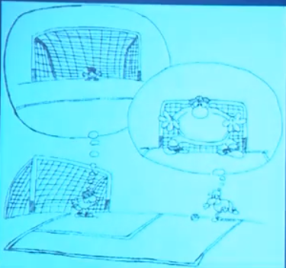
- As can be seen in this cartoon, a soccer player is on the point of making a penalty kick whereas a goalkeeper is preparing himself for it. Two different images pop up in their minds at the same time: the attacker is under the illusion that the goalkeeper is as big as the goal so that it is almost impossible for him to shoot in while the keeper, on the other hand, is daunted by the delusion that he turns helpless dwarf guarding a gigantic goal. （第一段）
- The lesson we can draw from this picture is clear and simple: all too often one overestimates the challenges and difficulties he faces and underrates his capabilities to cope with them. No man ever looks at this world with pristine eyes. He sees it edited by his own feelings and ways of thinking. This is especially the case when one is at a critical time in his life. Fears and tension preoccupy him at this very moment, truth distorted and confidence destroyed. （第二段）
- To calm his nerves and pluck up his courage, he has to realize what the truth is and admit that it is not the end of the world if he fails at this time. Then gradually, and often quite swiftly, the process of recuperation begins and a better result may be anticipated. （第三段）

Even in his philosophical probings he cannot go behind these stereotypes; his very concepts of the true and the false will still have reference to his particular traditional customs.

语法分析：
Even in his philosophical probings he cannot go behind these stereotypes; his very concepts of the true and the false（后置定语） will still have reference to his particular traditional customs.

知识点（1）【词汇】
probe v. 英文解释：to ask questions in order to find out secret or hidden information about sb./sth. 打探，探究，调查
- He didn’t like the media probing into his past.
- a TV programme that probed government scandals in the 1990s

知识点（2）【词汇】
stereotype n. [C] 英文解释：image, idea, character, etc. that has become fixed or standardized in a conventional form without individuality 陈规，老一套，旧框框

- He doesn’t conform to the usual stereotype of the city businessman with a dark suit and rolled umbrella. 他不像典型的城市商人那样, 穿一身深色的西装、带一把收好的雨伞。

【形近词辨析】
prototype n. [C] 英文解释：first or original example of sth. that has been or will be copied or developed; model or preliminary version 事物之原始形态，原型，雏形，模型，蓝本
- the prototype for future school buildings 未来的学校建筑的模型
- a prototype supersonic aircraft 超音速飞机的样机

知识点（4）【词汇】
very adj. (used to emphasize a n. 用以加强名词的语气) 正是
- He knows our very thoughts. 他了解我们内心深处的想法。
- The very idea of going abroad delighted him. 他想到出国一事就很欢喜。

知识点（5）
have reference to … 与……有关
- This has no reference to what we were discussing.

John Dewey has said in all seriousness that the part played by custom in shaping the behaviour of the individual, as against any way in which he can affect traditional custom, is as the proportion of the total vocabulary of his mother tongue against those words of his own baby talk that are taken up into the vernacular of his family.

语法分析：
John Dewey has said in all seriousness（状语前置） that the part played by custom in shaping the behaviour of the individual（后置定语）, as against（…A 和 …B 相比…） any way（方面） in which he can affect traditional custom（which...定语从句）, is as（… 就如同…） the proportion of the total vocabulary of his mother tongue（后置定语） against（…C 和 …D 相比…一样） those words of his own baby talk that are taken up into the vernacular of his family（that...定语从句）（that… 宾语从句）.

知识点（1）课文人物介绍
John Dewey American philosopher, psychologist and educator

知识点（2）Lesson04-44 高级比较
语法：A as against B is as C against D …A 和 …B 相比…, 就如同…C 和 …D 相比…一样
- The military power of the US, as against that of DPRK, is as the strength of an elephant against that of a mouse.
- John Dewey has said in all seriousness that the part played by custom in shaping the behaviour of the individual, as against any way in which he can affect traditional custom, is as the proportion of the total vocabulary of his mother tongue against those words of his own baby talk that are taken up into the vernacular of his family.

知识点（3）
take sth ⇔ up 英文解释：to accept a suggestion, offer, or idea 接受
- Rob took up the invitation to visit.

知识点（4）【词汇】
vernacular n. [C] 英文解释：language or dialect spoken in a particular country or region, as compared with a formal or written language 本地话，方言土语

When one seriously studies the social orders that have had the opportunity to develop autonomously, the figure becomes no more than an exact and matter-of-fact observation.

语法分析：
When one seriously studies the social orders that have had the opportunity to develop autonomously（that ...定语从句）（when... 时间状语从句）, the figure（这个比喻） becomes no more than an exact and matter-of-fact observation.

知识点（1）【词汇】
autonomous adj. 自治的，独立的
- They proudly declared themselves part of a new autonomous province.
- He treated us as autonomous individuals who had to learn to make up our own minds about important issues.

知识点（2）【词汇】
figure n. figure of speech 比喻
- ‘Get up with the lark’ is a figure (of speech), meaning 'Get out of bed early'.

知识点（3）
no more than: only 只不过
- It will take no more than five days to read the book.
- It's no more than a misunderstanding.

知识点（4）【词汇】
matter-of-fact adj. 英文解释：showing no emotion when you are talking about sth. exciting, frightening, upsetting etc. 不带个人情感的
- She told us the news of his death in a very matter-of-fact way.
- He was very matter-of-fact about the breakdown of his marriage.

知识点（5）【词汇】
observation n. 英文解释：remark or comment 言语，评论
- She made one or two observations about the weather.

The life history of the individual is first and foremost an accommodation to the patterns and standards traditionally handed down in his community.

语法分析：
The life history of the individual（后置定语） is first and foremost（状语，首先） an accommodation to the patterns and standards traditionally handed down in his community（后置定语）（后置定语）.

知识点（1）
first and foremost 英文解释：more than anything else, firstly and most importantly 首要地，主要
- He does a bit of writing, but first and foremost he’s a teacher.
- First and foremost, we have to consider the morality of the enterprise．

知识点（2）【词汇】
accommodation to sth. 对……的适应
- the accommodation of my plans to yours

【同根词】
accommodate to sth. 适应……
- Her eyes took a while to accommodate to the darkness.

知识点（3）Lesson04-01
hand sth. down 英文解释：pass sth. from older people to younger ones
- The recipe was handed down from an ancestor of the family.
- The only way that they can preserve their history is to recount it as sagas—legends handed down from one generation of storytellers to another.

知识点（4）【词汇】
community n. 英文解释： a group of people who have the same interests, religion, race etc. 集体，群体

From the moment of his birth, the customs into which he is born shape his experience and behaviour.

语法分析：
From the moment of his birth（时间状语）, the customs into which he is born shape his experience and behaviour.

By the time he can talk, he is the little creature of his culture, and by the time he is grown and able to take part in its activities, its habits are his habits, its beliefs his beliefs, its impossibilities his impossibilities.

语法分析：
By the time he can talk（时间状语）, he is the little creature of his culture, and by the time he is grown and able to take part in its activities（时间状语）, its habits are his habits, its beliefs (are) his beliefs, its impossibilities (are) his impossibilities.

知识点（1）【词汇】
creature n. 英文解释：someone who is controlled or influenced a lot by sth. 产物，奴隶，傀儡

creature of … … 的产物，奴隶，傀儡
- a creature of habit
- He is a creature of the government.

Every child that is born into his group will share them with him, and no child born into one on the opposite side of the globe can ever achieve the thousandth part.

语法分析：
Every child that is born into his group（that ...定语从句） will share them with him, and no child born into one on the opposite side of the globe（后置定语） can ever achieve the thousandth part.

知识点（1）
be born in / into …
- I was born in（大地方） Tokyo.
- Meg was born into（小地方） a large family.

知识点（2）【词汇】Lesson04-24
share v. to 英文解释：have the same opinion, quality, or experience as sb. else 有 一样的，有共同的
- I believe my view is widely shared.
- In some moods, Nature shares it.

share sth. with sb. 与…有一样的
- People often share their political views with their parents.
- Stubbornness was a characteristic he shared with his mother.

There is no social problem it is more incumbent upon us to understand than this of the role of custom.

语法分析：
There is no social problem (which省略) It（形式主语） is more incumbent upon us to understand（to … 真正主语） than this (social problem省略) of the role of custom（定语从句）.

知识点（1）
it is incumbent upon / on sb. to do sth. 某人有责任做某事
- It is incumbent upon parents to control what their children watch on TV.

知识点（2）Lesson03-32、Lesson04-11、Lesson04-44
语法：形式主语做从句的主语
- There is no social problem (which省略) it is more incumbent upon us to understand than this of the role of custom.
- The most valuable find of all was the ship's log book, parts of which it was still possible to read.
- But in an old man who has known human joys and sorrows, and has achieved whatever work it was in him to do, the fear of death is somewhat abject and ignoble.

Until we are intelligent as to its laws and varieties, the main complicating facts of human life must remain unintelligible.

语法分析：
Until we are intelligent(了解的) as to (关于) its laws and varieties（时间状语从句）, the main complicating facts of human life（后置定语） must remain unintelligible.

知识点（1）【词汇】
intelligent adj. 英文解释：showing powers of understanding 能够理解的，了解的
- The vast majority of us are not intelligent about the whole thing.

知识点（2）介词
as to prep. 关于，对于
= about
= with regard to
- He was uncertain as to which road to take.
- We are puzzled as to how it happened.

知识点（3）【词汇】
unintelligible adj. 英文解释：impossible to understand 不可能理解的，难懂的
- What he said was completely unintelligible to me because he used many technical terms.

（第三段）

The study of custom can be profitable only after certain preliminary propositions have been accepted, and some of these propositions have been violently opposed.

语法分析：
The study of custom can be profitable only after（只到….才） certain preliminary propositions have been accepted, and some of these propositions have been violently opposed（时间状语从句）.

知识点（1）【词汇】
preliminary adj. 英文解释：coming before a more important action or event, preparatory 开端的，初步的，预备性的
- after a few preliminary remarks
- preliminary inquiries / experiments / negotiations
- a preliminary contest

知识点（2）【词汇】
proposition n. 英文解释：statement that expresses a judgement or an opinion, assertion 观点，见解，主张
- The proposition is so clear that it needs no explanation.
- I approve of the proposition that love alone can waken love.

In the first place, any scientific study requires that there be no preferential weighting of one or another of the items in the series it selects for its consideration.

语法分析：
In the first place（首先）, any scientific study requires that there be（虚拟，should do型虚拟语气） no preferential weighting of one or another of the items in the series it selects for its consideration（定语从句）（that… 宾语从句）.
知识点（1）
In the first place 首先
= first / firstly
= first of all
= to begin with
= to start with
- In the first place, I’m too busy, and in the second, I don’t really want to go.

知识点（2）【词汇】
preferential adj. 英文解释：of, giving, receiving or showing preference 优先的，给予优先的，得到优先的，优待的
- Europe has given Caribbean banana growers preferential treatment for more than 20 years.

知识点（3）【词汇】
weight vt. [esp passive 尤用於被动语态] 英文解释：plan or organize (sth.) in a way that favours a particular person or group, bias 计划或组织（某事物）使之偏向某人或某集体，使偏袒
- a law weighted against those owning land 对土地持有者不利的法规
- a law weighted in favour of those owning land 对土地持有者偏袒的法规

In all the less controversial fields, like the study of cacti or termites or the nature of nebulae, the necessary method of study is to group the relevant material and to take note of all possible variant forms and conditions.

语法分析：
In all the less controversial fields（介词短语做状语）, like the study of cacti or termites or the nature of nebulae（插入语）, the necessary method of study is to group the relevant material（to … 不定式做表语1） and to take note of all possible variant forms and conditions（to … 不定式做表语2）.

知识点（1）【词汇】
group v. 英文解释：to make sb./sth. form a group 使聚集，汇集
- The children grouped themselves around their teacher.
- All the multiple choice questions will be grouped together for convenience.
知识点（2）
take note of sth. 注意……
= pay attention to sth.
= take notice of sth.
- People were beginning to take note of her talents as a writer.

知识点（3）【词汇】
variant adj. 英文解释：having or exhibiting variation; differing 相异的，不同的
- a variant form of the word
- a variant form of oxygen known as ozone

variant n. [C] 英文解释：sth. which is slightly different from other similar things 变种，变体
variant on / of … …的变种，变体
- There are many colas on the market now, all variants on the original drink.
- There are four variants of malaria, all transmitted to humans by a particular family of mosquitoes.

In this way, we have learned all that we know of the laws of astronomy, or of the habits of the social insects, let us say.

语法分析：
In this way（方式状语）, we have learned all that we know of the laws of astronomy, or of the habits of the social insects, let us say（that ...定语从句）.

知识点（1）Lesson03-29
(let’s) say : for example比如说（一般用于插入语）
- Why don’t we have a break until, (let’s) say, 10:45?
- Say / Let's say （充当连词，后面that可省略）(that) the journey takes three hours, you'll arrive at 2 o'clock.
- To see the problem here more clearly, let’s look at a different biological system, (let us) say, an acorn.
- The Americans would happily reach one accord on standards for medical devices and then hammer out different pacts covering, say, electronic goods and drug manufacturing.

It is only in the study of man himself that the major social sciences have substituted the study of one local variation, that of Western civilization.

语法分析：
It is（强调句，强调地点） only in the study of man himself that the major social sciences have substituted the study of one local variation, that of Western civilization（同位语）.

语法分析：补全
It is only in the study of man himself that the major social sciences have substituted the study of one local variation, that of Western civilization, (for the study of custom of all human beings).

知识点（1）
substitute A for B 用A取代B
【辨析】
replace B with A 用A取代B

- You can substitute chicken for beef if you don’t like red meat.
- You can replace beef with chicken if you don’t like red meat.

（第四段）

Anthropology was by definition impossible, as long as these distinctions between ourselves and the primitive, ourselves and the barbarian, ourselves and the pagan, held sway over people's minds.

语法分析：
Anthropology was by definition（方式状语） impossible, as long as（只要） these distinctions between ourselves and the primitive, ourselves and the barbarian, ourselves and the pagan（后置定语）, held sway over people's minds（条件状语从句）.

知识点（1）
by definition 英文解释：if sth. has a particular quality by definition, it must have that quality because all things of that type have it 从本质上来说
- People say that students are by definition idealistic and impatient.
- Human perception is highly imperfect and by definition subjective.

知识点（2）
hold sway 英文解释：to be the main influence on people’s opinions or behavior 占主导地位
- The traditional idea of wearing new clothes on New Year’s day seems no longer to hold sway.

It was necessary first to arrive at that degree of sophistication where we no longer set our own belief against our neighbour's superstition.

语法分析：
It（形式主语） was necessary first to arrive at that degree of sophistication where we no longer set our own belief against our neighbour's superstition（定语从句）（to … 真正主语）.

知识点（1）
set … against … 英文解释：make sb. oppose or be hostile to (a friend, relative, etc.) 使某人反对或敌视（朋友、亲戚等）
- The civil war set brother against brother.
- She accused her husband of setting their children against her.

It was necessary to recognize that these institutions which are based on the same premises, let us say the supernatural, must be considered together, our own among the rest.

语法分析：
It（形式主语） was necessary to recognize that these institutions which are based on the same premises, let us say the supernatural（which...定语从句）, must be considered together, our own (being) among the rest（独立主格，方式状语）（that… 宾语从句）（to … 真正主语）..

知识点（1）【词汇】
premise n. 英文解释：statement or idea on which reasoning is based, hypothesis（推理所依据的）前提，假定
- Advice to investors was based on the premise that interest rates would continue to fall.

知识点（2）【词汇】
supernatural adj. 英文解释：that cannot be explained by natural or physical laws 超自然的
- supernatural beings, eg angels and devils
- witch-doctors believed to have supernatural powers

知识点（3）
- our own (being) among the rest 独立主格

知识点（4）Lesson04-40
be among … 是……之一；包括在……之中
- He was among the last to leave.
- Among those present were the Prime Minister and her husband.
- These ocean waves are among the earth's most complicated natural phenomena.

